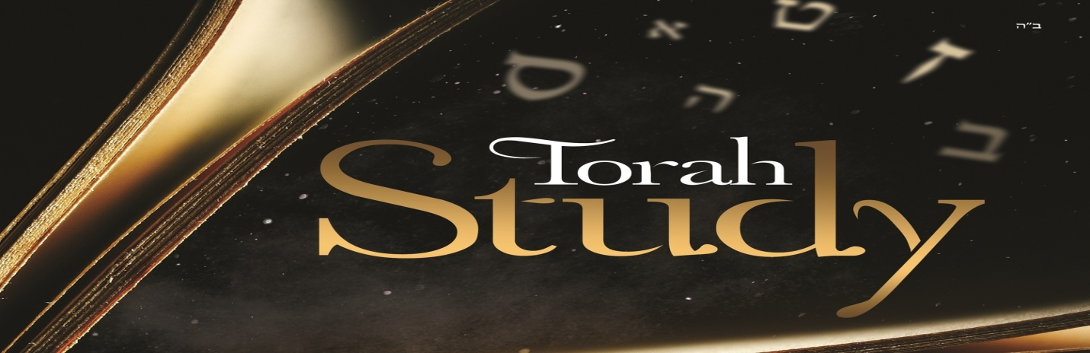
And beginning with Moses and all the Prophets, Jesus interpreted to them in all the Scriptures the things concerning Himself. –Luke 24:27

Themes
Messianic Seed
Sin and the Law
The Covenants
God’s Presence
The Human Heart
Atonement

God’s Presence
Genesis 2:4-25
- What are ways that would describe God’s relationship with Adam and the woman?
- What action did God take immediately following His declaration that “it is not good for man to be alone?”
- In his book, Biblical Knowing, Dru Johnson suggests that the primary error of Adam and Eve in Genesis 3 is not a desire for autonomy, but instead was a willful shift of their trust from the voice of God to the voice of the serpent. Therefore, their sin was a failure to listen to the correct voice. From what we have studied in previous weeks about God’s dealings with His people post-fall, how does this view contribute to our understanding of God’s intentions pre-fall and subsequently the state in which he wants to return His creation?

Exodus 20:18-21, 26:31-33, 34:29-35
- What themes do you see repeated?
- What is the purpose of the veil?
- Following Jesus’ crucifixion, the veil of the temple was torn. Why is this significant for believers today?

Leviticus 26:3-13
- Why does God expect obedience?
- If they obey his instructions and teachings, what result/reward do they get?

Joel 2:28-32
- When the New Covenant arrives, where will God’s presence be in the equation?

Psalm 1:1-6, 16:1-11
- What does it mean to meditate on the Lord day and night; what does that actually look like?
- What are the results when we meditate on the Lord?

John 4:1-26 try reading/listening to this text as if it is the first time
- In light of the Psalms passages above, what does it mean to know Jesus?
- In verses 19-20, the woman says that worship happens in a specific place. What is Jesus’ response to that statement?
- In light of the New Covenant prophecy, what is Jesus announcing as both “coming” and “now” simultaneously?

1 Corinthians 3:1-17, 6:7-20
- Believers today are instructed that their bodies are holy temples. What do these passages suggest to be the basis for constructing these holy temples?
- What is the basis for our foundation?
- How can believers today glorify God with our bodies?

Revelation 21:1-5, 22:1-5
- It is a peculiar thing that in Genesis 1, God created light before He created the sun, moon, and stars. In an increasingly science-driven culture, and in light of these two passages in the final pages of scripture, what is the purpose of light?
- With what we have read in previous weeks, particularly in Exodus, what significance is it that on the New Earth we will see God’s face?
- In what ways does the picture of the New Earth resemble the picture of Eden before the Fall?

Questions to Consider
- Part of God’s mission revealed throughout the Bible was to restore creation to its original state, and one day will be. In what ways has that process already begun and what things are we still waiting for?
- In what ways do believers today still treat God as if there is a veil between us?
- Drawing back on Psalm 1, do you have any examples you are willing to share of times in your own life when you were able to endure adversity because you were firmly planted by the living water of the Word?
- What role does the call for believers today to live holy lives play in our journey of sanctification?
- If our bodies are holy temples of the Spirit of the Lord, what are we doing to God when we sin?

No Sunday School next week for Memorial Day.

